

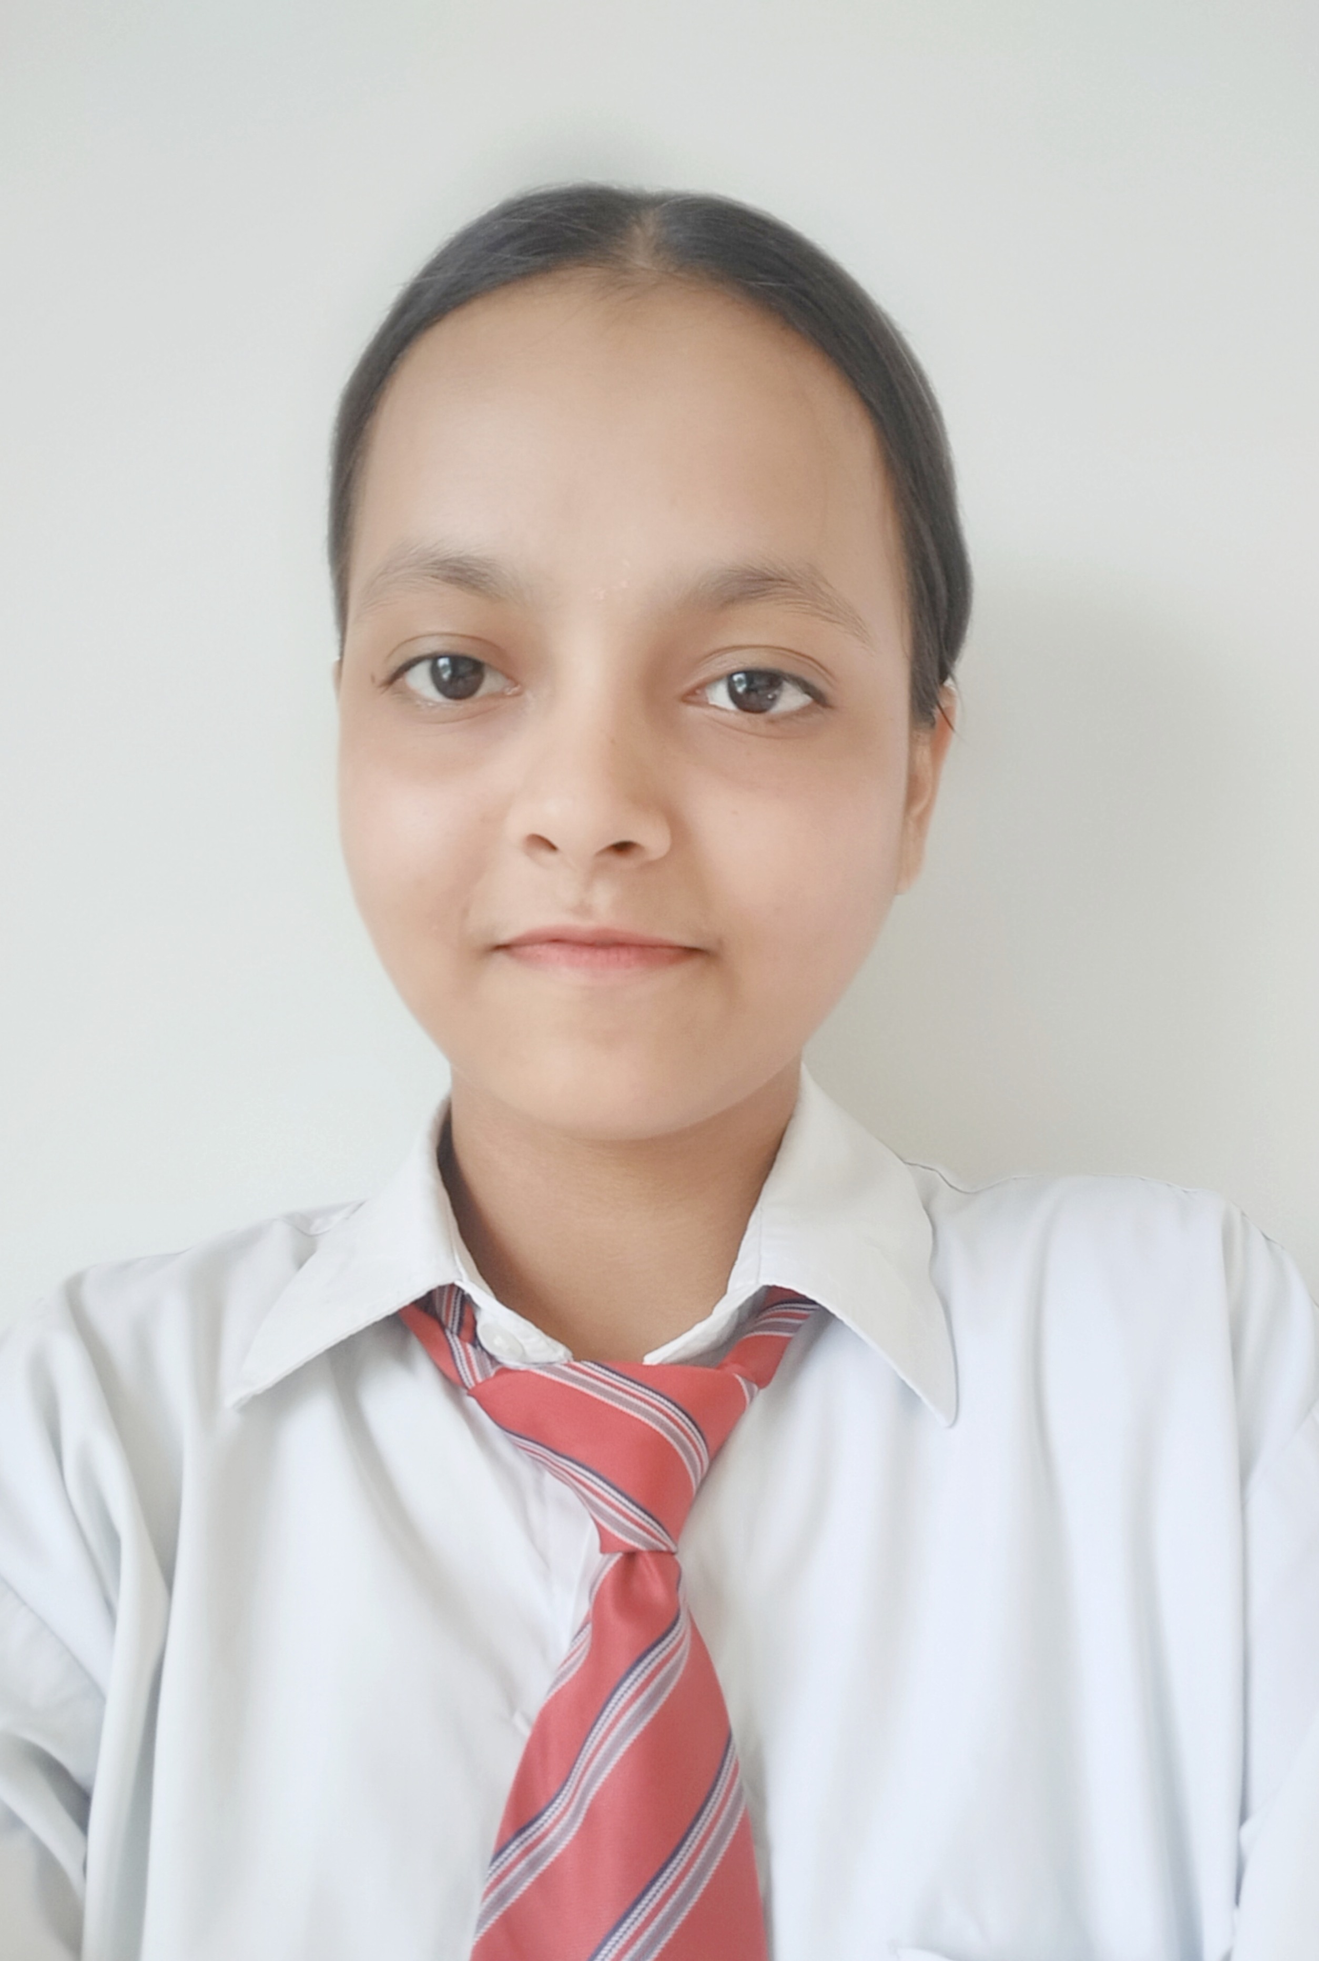

Juli Singh

#103 Nanaksar colony ,kurali mohali140103

9056013729

[2101650.cse.cec@cgc.edu.in](mailto:2101650.cse.cec@cgc.edu.in) <https://www.linkedin.com/in/juli-singh-871954243>

PROFESSIONAL SUMMARY

Recent computer science engineering graduate with coding knowledge in different programming languages .Professional with advance knowledge of designing and building computer network and system .A motivated and dedicated individual seeking a position that involves regular use of these skills . To work in a comparative and growth oriented environment where an individual is trusted with the due responsibilities and provided Ample of resources to add to their skills at and to the  organisation as whole.

TECHNICAL COMPETENCIES

**OS:** Windows

**Languages:** C |C++ | Java | Python | HTML

**Databases:** MS Access, MySQL.

**Other Interests:** Software Engineering, Operating System.

INTERPERSONAL SKILLS

Team Leadership |active listener| Management & Coordination |Writing Skills|positivity

INTERESTS & HOBBIES

Reading | Writing | playing baadminton| Painting

LANGUAGES KNOWN

English | Hindi | Punjabi

EDUCATION

Bachelors of Technology in Computer Science Engineering | Chandigarh Group of Colleges, Landran

Session: 2021-2025 | Score: 8.0 CGPA upto 2nd semester

Intermediate (CBSE) | International Public Senior Sec. School, Kurali |Session: 2019-2020 | Percentage: 80%

Matriculation (CBSE) | International Public Senior Sec School, Kurali|Session: 2017-2018 | Percentage: 84%

TRAINING & PROJECTS

**Smart clock**

Duration: 1 Month

Environment: Windows

Languages/Database: python

Team Size: 2

* It is a application which will tell you the time digitally .you don’t have to buy other clocks .

**Travelling guide**

Duration: 45 Days

Environment: Windows, Android Studio

Languages/Database: Java, XML

Team Size: 2

* The android app provides the user which will guide you about what to travel and how much expenses will be there in trip .It will help the foreigner to visit our country.

ACADEMIC ACHIEVEMENTS

* Participated in group discussion competition and cleared the 1st round.
* Got selected in science project exhibition.
* Participated smartindiahackathon (SIH) and work on problem.

CERTIFICATIONS

* Infosysis certification on basics of python.
* Aws certification of aws academy cloud architecting.
* Training of android development in CGC Landran.

EXTRA CURRICULAR & CO-CURRICULAR ACHIEVEMENTS

* Participated in badminton tournament in college and attain 5th position and have a district level player experience.
* Participated in various events in college like dance group, poster making

PERSONAL DETAILS

Mother’s Name: Renu singh

Father’s Name:Chandra bhushan singh

D.O.B: 11/08/2003